Flow Charts

* Start - circle
* Input / output – kite
* Processing – rectangle
* Condition – diamond

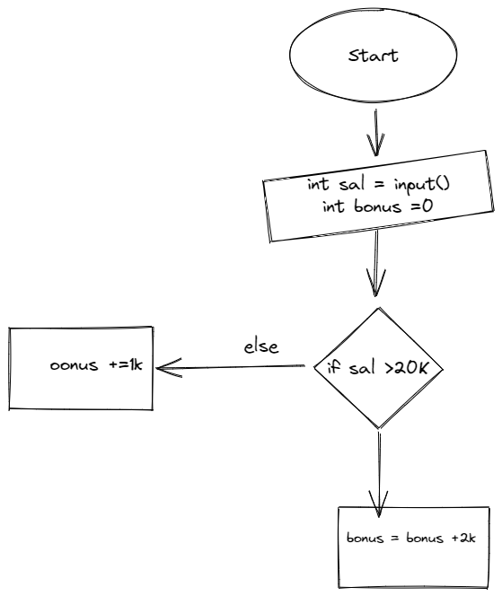

Input a number and checking whether the number is prime or not

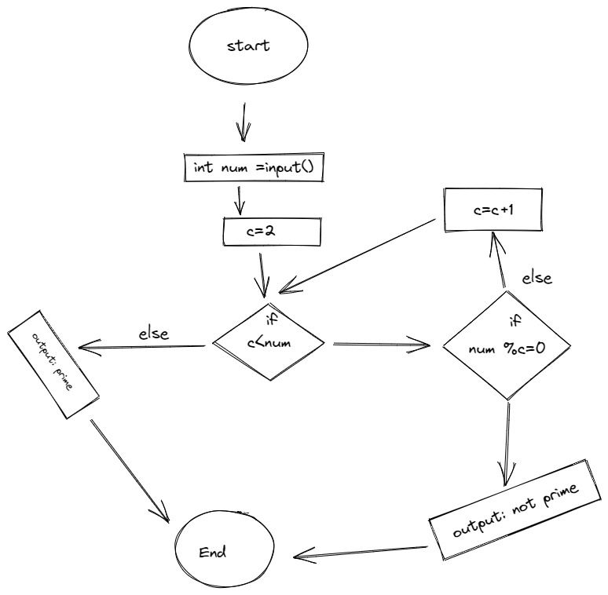

Pseudo Code

Prime num

Int num ;

c=2

Input(store it in num address )

While(c<num){

If(num ===1){  
print(“neither prime nor composite  
}

Else If( num %2 =0 ){  
print(“not prime”)

exit

}else {

C = c +1

}

Exit print(“prime”)

}

Salary

Enter

Input salary

If salary>10000

Salary = salary + 2000

Else{  
 Salary = Salary +1000

}

Optimizing the code

C\*C >num

/ c > sqrt(num)